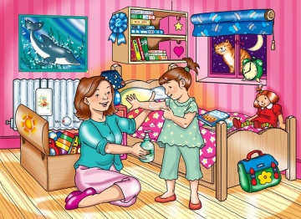
there is / there are
Affirmative

Singular – There is a doll
Plural – There are two pictures

Negative

Singular – There isn´t a book.
Plural – There aren´t any toys.
Questions

Singular – Is there a computer?
Plural – Are there any pictures?
some / any
Positive – There are some books Negative – There aren´t any balls Questions- Are there any toys?
Look at the picture. Circle the correct form:

There´s / there are a bike.
There´s / there are two pens.
There´s / there are a clock.
There´s / there are a bag.
There´s / there are two beds.
There´s / there are a ball.
Write there´s or there are .

_____________ a bag.
_____________ pillows.
_____________ some toys.
_____________ a doll.
_____________ a girl.
_____________ some books.
Look at the picture again and complete the sentences with: There is / there are / There isn´t or there aren´t:
_________________ a bedside table on the right.
_________________ a picture on the wall.
_________________ a fridge in the bedroom.
_________________a doll on the bed.
_________________ a carpet under the bed.
_________________some books on the shelf.
_________________ any flowers in the bedroom.

Complete the sentences with some or any:

Are there ____________ books in the bedroom?
There are ____________ books in the bedroom.
Are there ____________ windows in the bedroom?
There aren´t ____________ carpets on the floor.
There are ____________ pillows on the bed.

Look the picture again and describe the room.

Start like this:

In the bedroom there are ________________________________________________________________________________________________________________________________________________________________________________________________________________________________________________________________________________________________________________________________________________________________________________________________________________________________________________________________________________________________________________________________________________________________________________________________________________________________________________

