





….are you doing?
…….is he carrying?
…… is he disappearing?



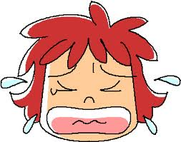

…….does he start work?
…. is the happiest?
.....colour is her hair?
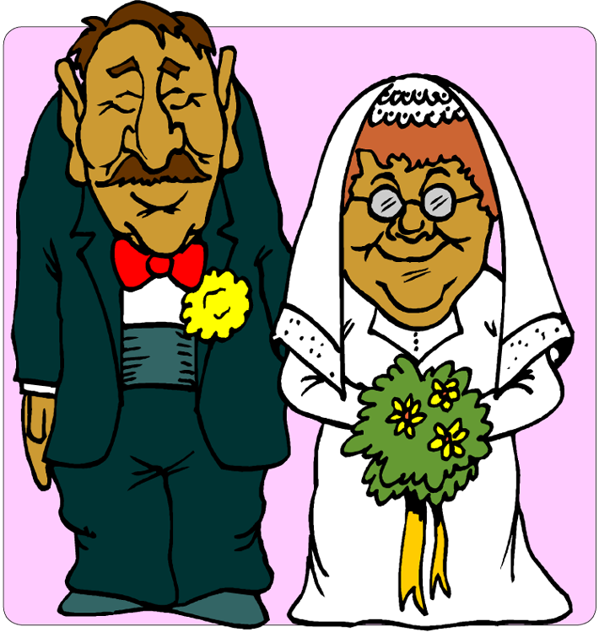
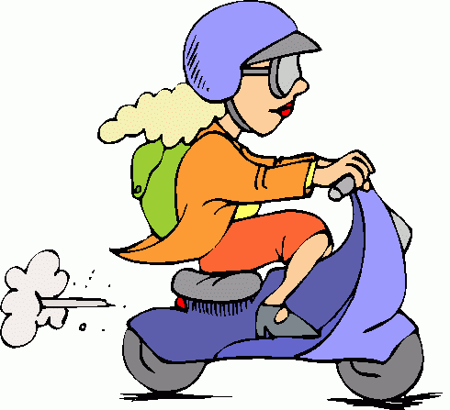
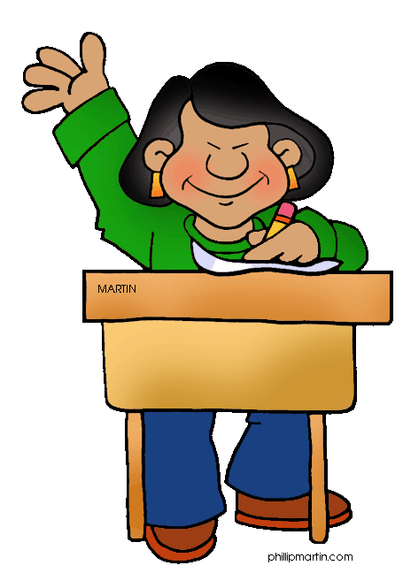

…..long have they been married?
…… does she go to work?
…… .old is she?





ru
……. are these books?
The teacher’s
……. is she begging?
…….. is he sitting?
…… is she talking to?


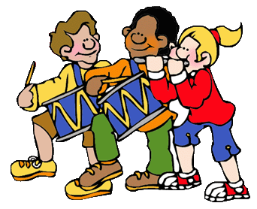

……. dress do you prefer?
……. are they playing? Drums
….. many candles are there on the cake? Six

ou
Arrange the words to make questions
1.- Julio/what/music/like/does
__________________________________________?
2.- is/Steve /repairing/brother’s car/where
__________________________________________?
3.- used/my dictionary/who/yesterday
_________________________________________?
4.-did/learn/ Sarah/ when/ to drive
_________________________________________?
5.- will/ you/visit/again/when/your grandparents
_________________________________________?
6.- fighting/ Patricia/is/Martin/why/with
_________________________________________?
7.- breakfast/have/you/what/for/do
_________________________________________?
8.- CDs/those/whose/are/on the table
_________________________________________?
9.- eat/often/does/how/your son/vegetables
_________________________________________?


