اكتب 3 جمل على الأقل التي تصف الصورة التي أمامك يمكنك الاستعانة بالمخزن

Look at the picture of Anna's room and write sentences

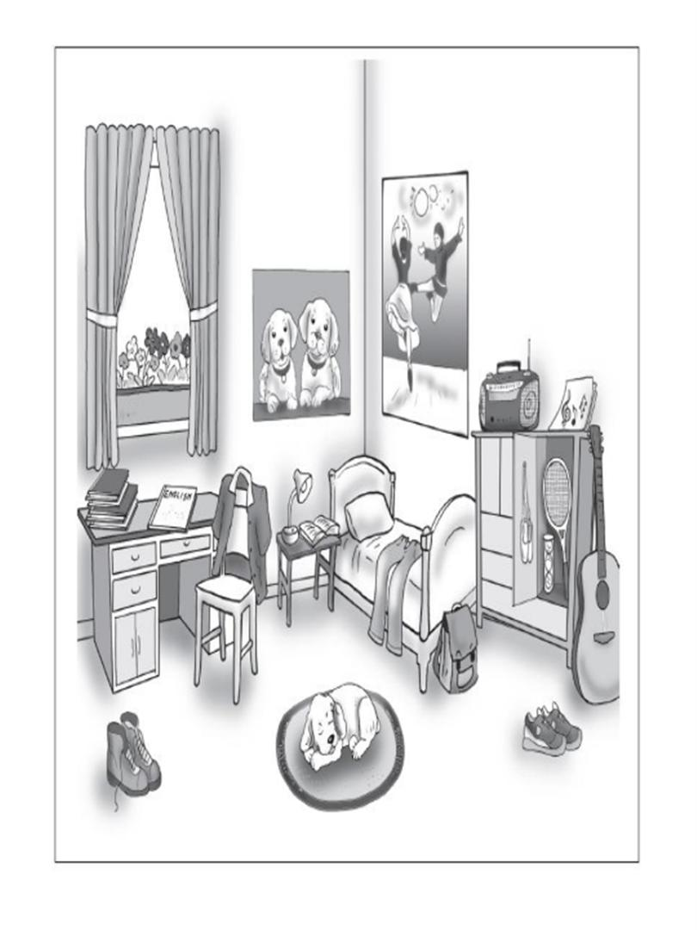

--------------------------------------------------------------------------------------------------------------------------------------

--------------------------------------------------------------------------------------------------------------------------------------

--------------------------------------------------------------------------------------------------------------------------------------

Write **one sentence** in English that describes **something that is happening in each picture**.

