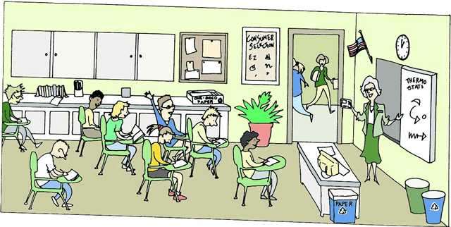Write 7 sentences about the next picture:

------------------------------------------------------------------------------------------------------------------------------------------------------------------------------------------------------------------------------------------------------------------------------------------------------------------------------------------------------------------------------------------------------------------------------------------------------------------------------------------------------------------------------------------------------------------------------------------------------------------------------------------------------------------------------------------------------------------------------------------------------------------------------------------------------------------------------------------------------------------------------------------------------------------------------------------------------------------------------------------------------------------------