**[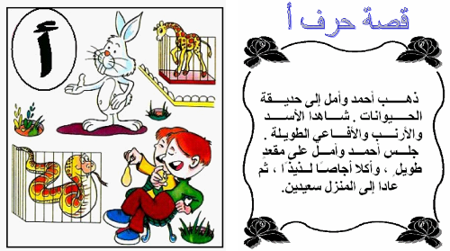](http://fashion.azyya.com/)**

**[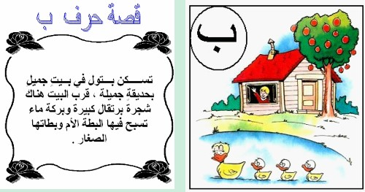](http://fashion.azyya.com/)**

**[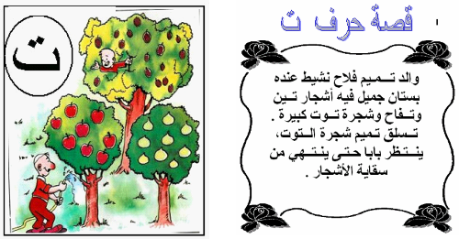](http://fashion.azyya.com/)**

**[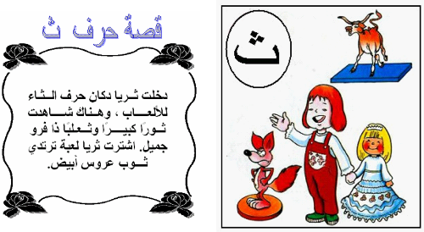](http://fashion.azyya.com/)**

**[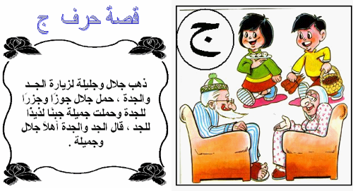](http://fashion.azyya.com/)**

http://www.qwled.com/vb/t205262.html