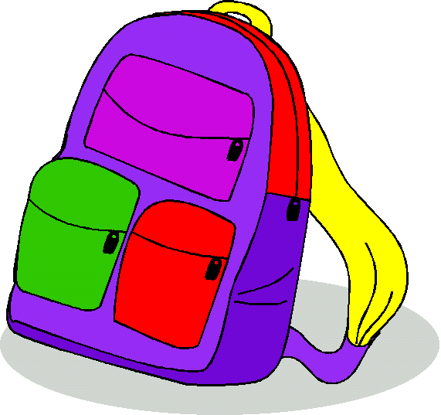

הַקִיפוּ בְּעִגוּל בָּלוֹנִים שֶׁסְכוּמָם ____.

10 | 35 | 25 | 15 | 10 | 10 | 40 | 35 | 0 | 15
13 | 0 | 35 | 0 | 3 | 7 | 12 | 25 | 30 | 12
7 | 15 | 5 | 10 | 5 | 30 | 0 | 5 | 14 | 35
32 | 8 | 25 | 15 | 5 | 15 | 8 | 10 | 6 | 24
20 | 29 | 0 | 10 | 5 | 5 | 12 | 15 | 6 | 44
9 | 0 | 10 | 17 | 20 | 30 | 20 | 4 | 11 | 5
10 | 25 | 40 | 3 | 25 | 2 | 28 | 13 | 7 | 30
25 | 30 | 10 | 40 | 25 | 25 | 10 | 15 | 25 | 30
15 | 0 | 5 | 25 | 20 | 11 | 5 | 5 | 8 | 40
10 | 10 | 10 | 10 | 10 | 9 | 20 | 13 | 7 | 10

