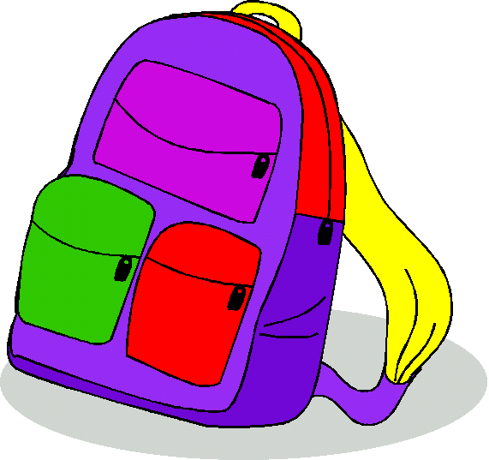
נְתַרְגֵל כֶּפֶל

___ | = | 12 | × | 2 |  | ___ | = | 3 | × | 6
___ | = | 11 | × | 3 |  | ___ | = | 3 | × | 5
___ | = | 1 | × | 15 |  | ___ | = | 2 | × | 8
___ | = | 12 | × | 4 |  | ___ | = | 9 | × | 9
___ | = | 9 | × | 10 |  | ___ | = | 7 | × | 6
___ | = | 10 | × | 10 |  | ___ | = | 4 | × | 5
___ | = | 8 | × | 8 |  | ___ | = | 9 | × | 3
___ | = | 1 | × | 1 |  | ___ | = | 4 | × | 7
___ | = | 2 | × | 2 |  | ___ | = | 9 | × | 5
___ | = | 3 | × | 3 |  | ___ | = | 6 | × | 10
___ | = | 4 | × | 4 |  | ___ | = | 0 | × | 3
___ | = | 5 | × | 5 |  | ___ | = | 8 | × | 9
___ | = | 6 | × | 6 |  | ___ | = | 9 | × | 8
___ | = | 7 | × | 7 |  | ___ | = | 3 | × | 5

