Al -Qasemi College

English Department
Second Year
Nouns as adjectives
Reham Egbarie
ID: 305124299
Submitted to: Dr. Ali

Description of Class: | This is a mixed ability class, the students are slow learners and some of them are good learners. But I briefer to teach in middle level to give all students the opportunity to learn and get new information
Domains

- Social Interaction
- Presentation

Goals (General)  - Social Interaction  - Presentation | Objectives (Specific)  - Understand and identify what a noun is.  - Understand and identify what an adjective is.  - Use nouns and adjectives correctly in sentences.  - Students will identify nouns as adjectives.  - Students will use “nouns as Adjectives” in sentences.  - Students will be able to write sentences.  - Students will learn new vocabulary.  - Students will be able to work as team.
Required Materials:
Worksheet.

Teaching Methodology/Techniques |  | Time
Opening/ Entry Behavior/ Warm up Activity:

After grating students and write day and date, I will start with students with a small activity to warm up their minds:
I will give students set of sentences and they will write the nouns and adjectives in the sentences in the right columns, each two will work together.

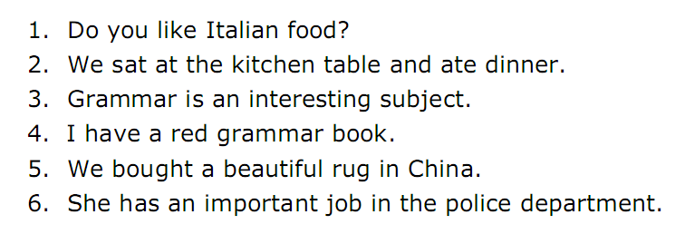
noun | adjective | Sentence number
Food | Italian | 1
Table, dinner |  | 2
 |  | 3
 |  | 4
 |  | 5
 |  | 6

Step-by-step Procedures/Body

Presentation:

After they finish the activity I will start the lesson with small introduction about:
Nouns and adjectives
As you know, a noun is a person, place or thing, and an adjective is a word that describes a noun:

Noun | Adjective
Teacher | Clever
Office | Small
Horse | Black

Practice : ( Controlled Practice and independent practice)

I will give students a text:
I will give students the text "Johnny Appleseed" and I will give every student to read one paragraph, while we are reading every paragraph I will ask them about the difficult words.
After we finish reading the text I will ask students to solve this exercise according to the text: True\False 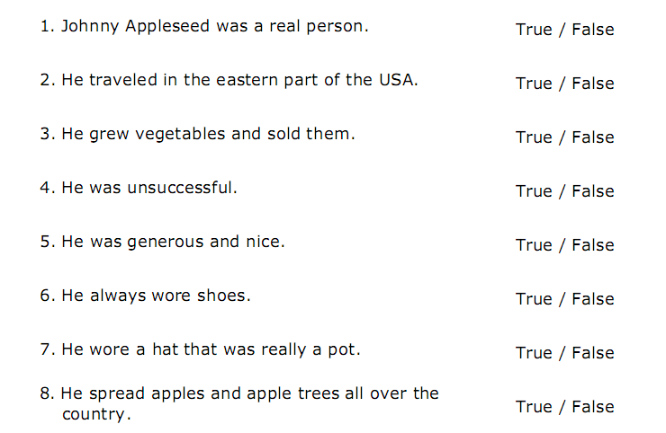

By this exercise students will understand the text very well.

Now we will move to our main subject of our lesson,
“ Nouns as Adjectives “
First I will make an activity to make it easier to understand.
I will divide the class into six groups each group will solve one sentence with knowing the word’s type ( N. Adj. Noun as Adjective ): 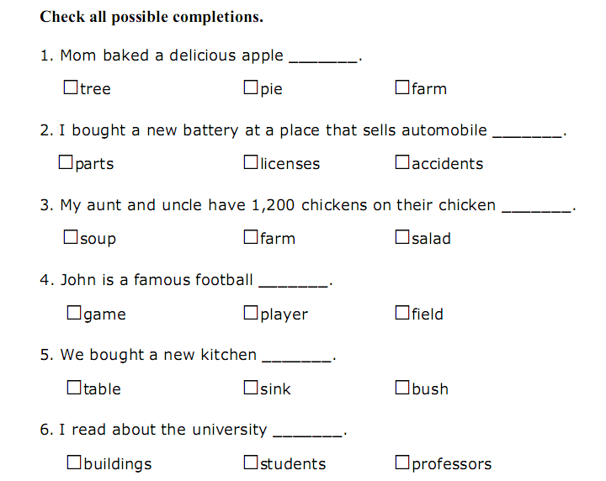

Then I will explain the “Nouns as Adjectives” in simple words with much of examples:
Sometimes we use a noun to describe another noun. In that case, the first Noun "acts as" an adjective.

noun  as adjective | noun
history | teacher
ticket | office
race | horse

Evaluation Strategies and Closure:

I will finish the lesson with this activity:
Each one of students will write 5 sentences with using our new subject:
“ Nouns as Adjectives ”

Homework:

I will give students worksheet to help them review the new vocabulary, in addition to it, I will give the students write small paragraph from 3-5 lines about any topic they like with using the "nouns as adjectives"

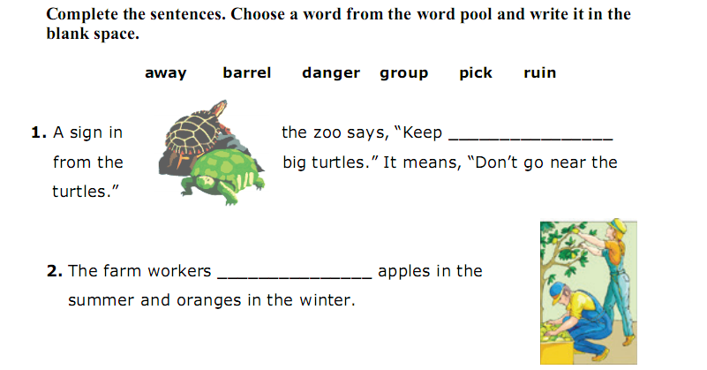
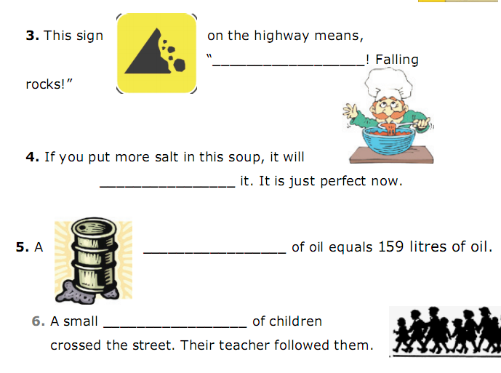
Pedagogical Guide’s Signature: | Student Teacher’s Signature:
Training Teacher’s Signature: | Observing Student’s Signature:

The text:

Johnny Appleseed

Johnny Appleseed was an American pioneer* and a legend. He loved apples. He grew apple trees and traveled around many places in the United States of America to bring apple trees to the people. Many people think that Johnny Appleseed was an imaginary character, but he was a real person. He was born in Massachusetts in 1774 and lived for
70 years.
Johnny had good farming skills. He planted apple trees and took good care of them. He supplied apple seeds to the early settlers in the Mid-west of the USA, the large part of the land in the middle of the country, far from the oceans. He owned tree farms in several states. He sold many trees, but gave away many, too. He was very successful, but he lived a simple life. He was kind and generous and friendly to everyone. And he did funny things! He liked to walk in his bare feet, and he wore his tin cooking pot on his head as he traveled.
His real name was John Chapman, but people called him Johnny Appleseed because of his great love for apples and their seeds. Johnny spent 50 years growing apple trees and spreading them successfully all over the land.

__________________________________________________
*The people who traveled west in the United States and made their homes in new places were called pioneers.

