Department of English Language and Literature
Department of Education- Pedagogical Guidance

A Lesson Plan Format
Descriptive Information/Background Information

School Name: | Date: 15/02/2012 | Lesson:
Pedagogical Guide:  Dr. Ali Jabarin | Text Book:  External material | Unit/ Page:  /
Training-Teacher Name: | Title of Lesson:  Possessive pronouns
Student-Teacher Name:  Hiba Younis | Content Area:  Access to information  Appreciation of a language

Description of Class:  (a high aptitude class, a mixed ability class,  slow learners, unmotivated learners) | Mixed ability class
Goals (General)  I want my students to be able to:  - Interact effectively through social context.  - Understand the possessive pronouns.  - Using the pronouns in contest. | Objectives (Specific)  each student will be able to:  - Speak orally and to express their opinion about the pictures.  - Enable the students to assimilate the correct possessive pronouns of the language.  - Independently identify possessive pronouns in any sentence they may take.
Required Materials:
Board: I will use the board to paste the cards (that include pictures) and I will write on it the answers of the questions.
Markers: I will use markers to write notes and answers for the questions.
Pictures: I will paste five pictures on the board.
Glue pads: I will use them to paste the pictures.
Worksheet: I will give the pupils a worksheet to answer the questions in it.
Projector: I will use the projector to show the pupils a presentation and a short video.

Teaching Methodology/Techniques |  | Time
Opening/ Entry Behavior/ Warm up Activity:  When I will enter into the class I will great the students, then I will ask them about the day and date. After writing the day and th4e date on the board. I will hang some pictures on the board  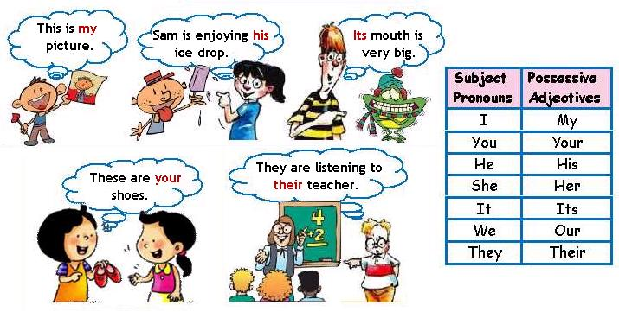  After showing them these pictures, I will ask five students to come on the board and each one read a sentence from the pictures, after reading the sentences I will ask them to read loudly the words which are highlighted in red. After this I will ask the class if they know what we call these words . if they don’t know I will help them, and write the title on the board. Then I will explain the possessive pronouns.  Step-by-step Procedures/Body  Presentation:  - After finishing the warm-up activity, I will explain the possessive pronouns through a presentation, where I explain first the definition and then the use of possessive pronouns and illustrate some examples.  - After that I will give the students this poem:  I have a toy  The toy is for me  It is my toy  The toy is mine  I will ask different students to read it loudly, after that I will ask them to highlight the words "I" in line one, "me" in line two, "my" in line three and "mine" in line four. They could highlight these words or circle them or write them in colors. any way to show that these words are the focus.  Then I will tell them that the poem has other versions. Let’s change the "I" in line one to "you" and see how the other words that were highlighted change too.  You have a toy  The toy is for you  It is your toy  The toy is yours  Depending on the level of my students and how fast they can memorize, I will move on to the other versions with "He", "She", "It", "We", "They" .  - After this exercise I will give the students a worksheet. first we are going to read it together and explain the questions, then I will give them 7 min to solve the answers because I will not give them a lot of questions. Then we will answer the questions together.  - I will give the pupils a homework about the possessive pronouns. And I will explain the homework for the pupils.  Practice : ( Controlled Practice and independent practice)  Controlled Practice:  We will do the Warm-up activity together and we will solve the worksheet together.  Independent Practice:  The worksheet will be independent practice; they will solve the questions alone. After they finish we will do it together.  Evaluation Strategies:  Based on the questions I will ask and the worksheet I can evaluate their understanding.  Closure:  (Reflect your Objectives/Go Over What Went on in the Lesson  - I will show them a short video for 1:00 min which review all the materials .Then I will sum up asking about their feelings, what they liked the most? and what was difficult for them?.  http://www.youtube.com/watch?v=-IX4Y7gCQZQ |  | 5 min  11 min  10 min  13 min  3 min  3 min
Homework:
I will give the pupils a worksheet about nominative case to solve in their homes.

Reflection

Professional Development

Pedagogical Guide’s Signature: | Student Teacher’s Signature:
Training Teacher’s Signature: | Observing Student’s Signature:

The English Department Wishing You All the Best☺

