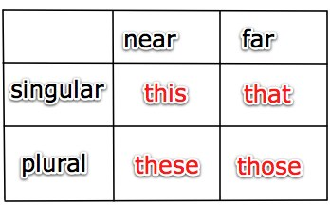

To point out people, things or places.
- We use this and that for singular nouns.
- We use these and those for plural nouns.
- We use this and these for nouns which are near.
- We use that and those for nouns which are far.

Exercise 1:
Circle the correct answer.
- I prefer (that/those) chair.
- Is (this/these) the girl you want me to meet?
- (This/These) are the new rules.
- (This/These) is the answer to question five.
- I don’t like (this/these) hotel.
- Who is (that/those)?
- Is (that/those) the new house you told me about?
- (This/These) isn’t the letter which I wrote.
- Are (these/this) the correct plates to use?
- (Those/That) birds sing beautifully, don’t they?

Excersice B:
B. Underline all the demonstrative pronouns in these sentences.
These are the worst brownies I have ever tasted. That is the truth. Such a good try, and yet, none are edible. I should try these cookies instead. I will have this or that, and find something delicious. I will forget this ever happened and eat those brownies again. I tasted two cookies and neither is much better than the brownies. This is awful. Such is life!

Exercise C:
In the following sentences, underline the demonstrative pronoun and put an S if it is singular and a P if it is plural.
- ___ That is the biggest horse I ever saw.
- ___ These are delicious cookies.
- ___ I saw you do that.
- ___ I don’t understand this.
- ___ Those are your only choices.



