**"True Friend"**

***Hannah Montana***

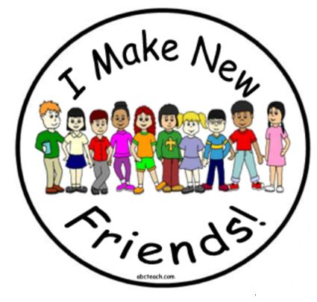We sign our cards and letters BFF  
You've got a _________ ways to make me laugh  
You're lookin' out for me, you've got my back  
So good to have you around  
You know the secrets I could never tell  
And when I'm quiet you break through my shell  
Don't feel the need to do a rebel yell  
'Cause you keep my feet on the _________  
  
You're a true friend  
You're here till the end  
You pull me aside when something ain't right  
Talk with me now and into the night  
'Til it's alright _________  
You're a true friend  
  
You don't get angry when I change the plans  
Somehow you're never out of second chances  
Won't say "I told you" when I'm wrong again  
I'm so _________ that I've found  
  
A true friend  
You're here till the end  
You pull me aside when something ain't right  
Talk with me now and into the night  
'Til it's alright again  
  
True friends will go to the ends of the earth  
Till they find the things you _________  
Friends hang on through the ups and the downs  
Cause they've got someone to _________ in  
  
A true friend  
You're here till the end  
You pull me aside when something ain't right  
Talk with me now and into the night  
No need to pretend  
You're a true friend  
  
You're a true friend  
You're _________ till the end  
You pull me aside when something ain't right  
Talk with me now and into the night  
'Til it's alright again  
You're a true friend  
You're a true friend