Hand out II
Stopping By Woods on a Snowy Evening
Robert Frost
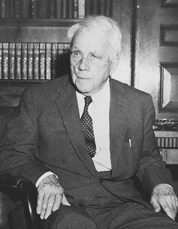

Whose woods these are I think I know.
His house is in the village though;
He will not see me stopping here
To watch his woods fill up with snow.
My little horse must think it queer
To stop without a farmhouse near
Between the woods and frozen lake
The darkest evening of the year.
He gives his harness bells a shake
To ask if there is some mistake.
The only other sound's the sweep
Of easy wind and downy flake.
The woods are lovely, dark and deep.
But I have promises to keep,
And miles to go before I sleep,
And miles to go before I sleep.

