HOTS: PREDICTION

Prediction – noun
divination; prophecy, soothsaying; forecasting, act of foretelling

1) General Questions:
- When you look outside what can you predict about the weather?

- Have you ever predicted something about a television show or movie?

- Do you ever know what someone else, like a family member or friend, will say in a particular situation?

- Have you ever been able to tell what you were going to eat for a meal before anyone told you?

- What can you tell about a story by looking at the cover of the book?

3) “What’s in the Bag interactive”:

Please follow the link here and try to guess what is in the bag:

What's in the bag?!

4) Let’s go to the movies!

Read the names of the following movies. What do you think these movies are about? Match each movie with its genre.
- Haunted House a. action movie
- The Runaway Bride b. romance
- Mission Impossible c. horror

5) The Ant and the Grasshopper:

Read the following story:
Once upon a time an ant and a grasshopper lived near each other.
All through the summer, the ant collected food for the winter, while the grasshopper played in the field.
When the winter came, the ant stayed at home. He had no worries at all.
He had enough food and his house was nice and warm.
One night there was a knock at his door. It was the grasshopper. “Please, please, please!” the grasshopper said, “please let me in! I am wet and I am so hungry.”
The ant just stood there and said, “Sorry! You played all through the summer, so you can cry all through the winter!”

- Imagine that the fable did not stop at this point, what do you predict will happen next? (Suggested answer: The Grasshopper ate the ant!!/ The ant felt sorry for the grasshopper... etc.)

6) What Will Happen Next?
a. Look at each picture. Draw what you think will happen next.
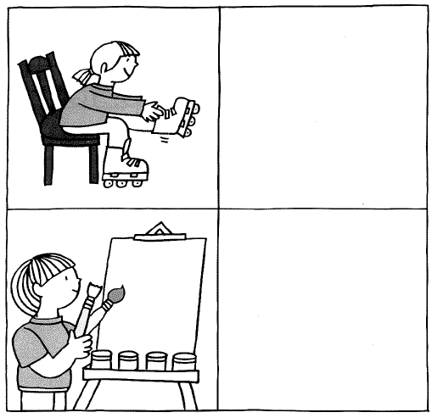

b. Watch the following video till (0:20):
Travel in Groups
- What do you think will happen next
- Now, keep watching till (1:04). What do you think will happen next?
---------------------------------------------------------------------------------
- Why do you think this will happen?
--------------------------------------------------------------------------------
- What did you base your answer on?
--------------------------------------------------------------------------------

* Based on the above activities, the term ‘prediction’ is based on:
- prior knowledge
- new information
- prior knowledge as well as new information

