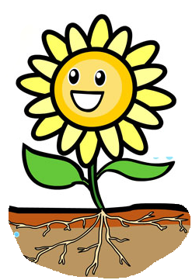
THE PHOTOSYNTHESIS SONG

If you want to know / How a plant grows / It takes water, air, and sunlight / And makes cellulose
Every plant can do this / Fundamental process / And we can call this / Photosynthesis
Unlike me and you / Plants need CO2 / And they make oxygen / That stops us turning blue
Every plant can do this / Fundamental process / And we can call this / Photosynthesis
It’s a miracle / How all the chlorophyll / Captures sunlight in the leaves / Of the plants and the trees
A plant of any size / Can do it if it tries / But we’re not green, so we can’t / photosynthesize
Every plant can do this / Fundamental process / And we can call this / Photosynthesis
It’s a miracle / How all the chlorophyll / Captures sunlight in the leaves / Of the plants and the trees
Every plant can do this / Fundamental process / And we can call this / Photosynthesis
Every plant can do this / Fundamental process / And we can call this / Pho-to-syn-the-sis
Photosynthesis

